Weather and Partisans

Weather
The map uses a has 3 weather zones. The severe, winter and temperate weather zones:
- Severe zone is Russia / Siberia / Canada
- Winter zone is US, most of Europe and most of China
- Temperate zone is everywhere else. The zones are below:
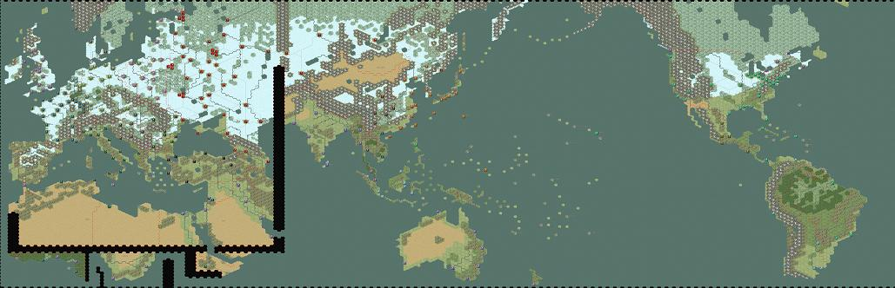
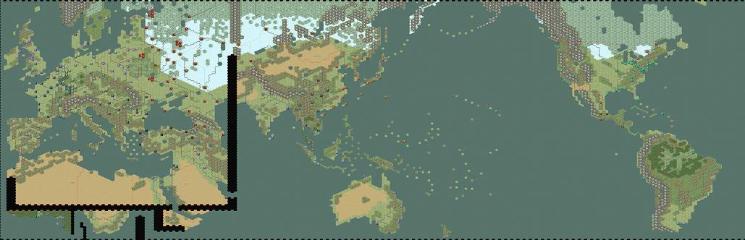
There are 3 weather states - (1) clear, (2) mud and (3) snow:
- Temperate zone is always clear
- Winter zone experience mud in November and March and snow from December through February
- Severe zone experiences mud in October and April and snow from November through March (note that there is more bad weather than good in Russia)
During mud weather, movement, especially vehicle movement, is severely restricted. Units take a 20% readiness penalty per round
During snow weather, units take a 35% readiness penalty per round
Weather does not affect airfields, ports, towns, cities or fortifications. Troops in these locations are in 'winter quarters'. Shelter your troops if they do not need to man front line positions.
Special Desert Penalty. Units in the desert take a 20% readiness penalty each turn.

Partisans
There are six partisan zones on the map. Each hex has a probability that a 5 partisan unit will arrive each round if occupied by the Axis. The applicable Allied power can increase this probability by 1 point by investing in Partisan I research and 2 points by investing in partisan II research. Likewise, the applicable Axis power can decrease probably similarly by investing in Anti-Partisan research.

1. The Soviet Union
Soviet partisans arrive in Soviet hexes (marked after the Soviet Union wakes up) West of the Urals. The base chance for a partisan unit is 2% per hex. The Soviets and German players can influence this through research. Partisan activity also increases 1 point if the variant “Soviet’s choose World Wide revolution” is selected.

2. Balkans
If the West succeeds in a coup against Yugoslavia, Hungary, Romania or Bulgaria; that country is marked for partisans. The base chance for partisans is 1% per hex. The West and German players can influence this through research. This probability increases by 1% when Germany and the Soviet Union are at war.

3. China
China partisans can arrive in China and Manchuria (south of Mukden) with a base probability of 3% once Japan and China are at war. China and Japan can influence this through research.

4. Indochina
Non-Euro partisans will arrive in Indochina once Japan and the West are at war. The base chance for partisans is 1% per hex. The West and Japan can influence this through research. This probability increases by 1% if the “Independent Indochina” variant is played.

5. France
Once the US is in the war and the Germans and Soviet’s are at war. There is a 1% base chance of partisan arrivals in continental France. The West and German players can influence this through research.

6. UK
If the UK is invaded, there is a 1% chance per hex of a partisan arrival. This increases by 1% once the US is at war. The West and the German players can influence this through research
Back to WAW scenario

