WAW Walk Through (German Perspective)
The following is an AAR from a game with Stuart, graphic artist extraordinaire. It should give you a good sense of the strategy of the game.

Turn 1. September 1, 1939
1. Research ‘Own People production – 75%’ to start gearing up economy.
2. German U-boat fleet turns off anti supply and tries to sneak out past the UK
3. Set Berlin product to 20 pilots, 40 steel, 30 engines based on a long term production ratio of 1 fighter to 1 dive bomber to 1 med tank to 2 artillery to 1 truck (2 pilots:4 steel :3 engines)
4. Shore bombardment of Danzig followed by 3 hex assault from 4th and 3rd armies.
5. 3rd Army clears hexes N and NW of Warsaw via assaults.
6. 4th Army from the north and 8th Army from the south converge and capture Poznan. Note that I use tanks, infantry and mechanized infantry to clear the plains hexes. The city assault uses infantry only (avoid tank assaults in city when possible.
7. 10th and 14th army take Krakow through a series of attacks. I used mechanized forces to clear the plains to the north and then exploit the hexes north and east of Krakow (cutting off Lublin).
8. Half of air force bombs Krakow with the other half bombing Warsaw. Attack on Warsaw is designed to limit counterattack. Also, I make sure every front line mech infantry ends it’s turn with an armored unit.
9. Casualties: Infantry (355 Poles - 50 Germans); Guns (58 Poles - 0 Germans); Trucks (0 Poles - 7 Germans); Tanks (3 Poles - 7 Germans), Planes (34 Poles - 7 Germans). Note that you will see higher truck and plane casualties than in AT when on the offensive so build accordingly.
Positions at end of turn:
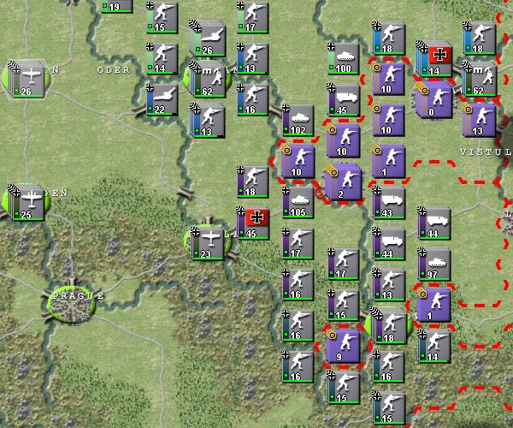

Turn 2. September 25, 1939
1. Warsaw is captured without too much difficulty after a series of assaults from the 3rd Army from the north and the 10th Army from the south. My entire air force is used against Warsaw in preparation for the assault. I also attack units outside of the remaining cities in order to build experience. I invest Lublin and Lodz. The units there will surrender next turn. Total casualties this turn are infantry – 221 Poles to 21 German; guns – 32 Poles to 1 German (lost to counter battery which is turned on); trucks – 0 Poles to 10 German (forward mech units end up in a lot of assaults); tanks – 17 Poles to 3 German; and planes – 1 Poles to 13 German.
2. For research, I research both ‘Euro People 50%’ and then ‘Euro People 75%’. The Poles (as well as the Axis Minors) are all Euro people. I want to gear up their production as well as my own. The cost of production research is a function of the base production being improved so this research is much less than the research to improve German production.
3. I also research a coup in Argentina and Brazil. Each has a 25% chance of working with a 10% chance of counter coup. A Latin American coup will give me a good base for U-boats. Unfortunately, my uboat fleet was discovered and destroyed.
4. I start to move my Army west.
5. Note that German aircraft losses might appear high relative to AT. However, this was done intentially. Historically in the Battle of Poland, the Luftwaffe lost, to all operational causes, 285 aircraft, with 279 more damaged (wikipedia) or about 15% of the planes deployed.
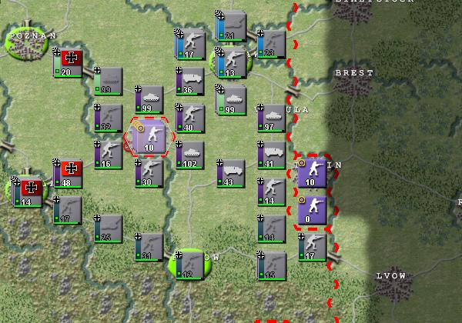

Turn 3. October 19, 1939
1. With Warsaw captured, the units in Lublin and Lodz surrender. Poland is complete.
2. My coup attempt in Brazil is thwarted but succeeds in Argentina. Argentina is an amalgamation of Spanish speaking South America. The oil field of Venezuela is nice (while it lasts). At least it gives the Royal Navy something to do over the winter months.
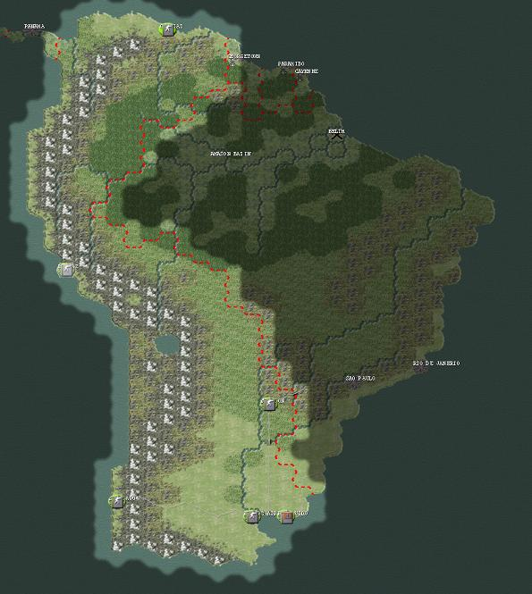
3. Winter will come next turn. It starts a turn earlier in the extreme weather zone (e.g., Siberia and Canada). I can see that it is changing. Winter does not affect units in cities or fortifications so it is important to get my units into winter quarters.
4. I see also that the Allies lobbied Roosevelt. I do the same. I have to make a decision on my general R&D strategy. I think I want to get both my own people production and Euro people production up to 100% and then start on tactical R&D with a focus on fighters, guns, infantry and tanks.
5. I also have to think about Denmark / Norway. You want can try to take it by coup or by conquest. I think I will hold off until Paris falls.

Turn 4. November 12, 1939
1. Turn is both quick and quite as I move my army to the West

Turn 5. December 6, 1939
1. The Royal Navy has moved into position off Venezuela to intercept supplies from Caracas. I split my unit in 2 in order to see it I can quickly grab Georgetown to the East but find it garrisoned. It is always crucial to have a port in order to successfully invade so the writing is on the wall for Caracas.
2. Winter has come early in Northern Europe. I move my army to winter quarters (e.g., all units in cities or fortifications). Units out in the field will take an additional readiness penalty. I also set up a network of fighters to prevent any bombing. (See below)
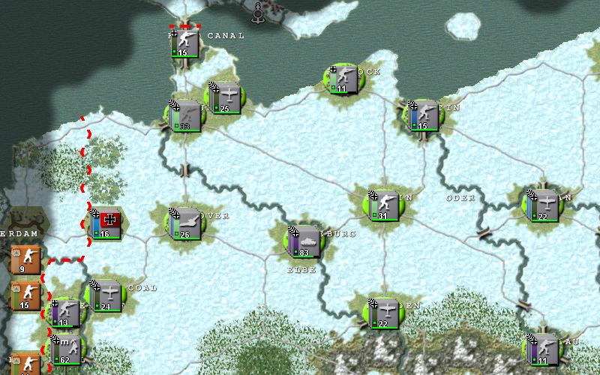
3. Last turn, I set up a 1 unit bomber unit to probe the British air defenses near Edinburgh. I found that there were fighters in range so I aborted my main bomber run. Note that as a tactic, it is always better to probe with a lone bomber than risk flying into a fighter trap. Bombers are expensive (costing 2 engines), so you do not want to be careless with them.

Turn 6. December 30, 1939
1. The Allies are bombing my positions in South America. Nothing I can do but hold on for now.
2. I start researching to improve my units. I start researching both Infantry and Fighters. Unlike AT, research is not immediate. Every turn, there is an 8% chance that I will get the improved units. So on average, I will have to wait 12 turns. Hopefully I will be lucky and get at least 1 early breakthrough in time for the offensive vs France.
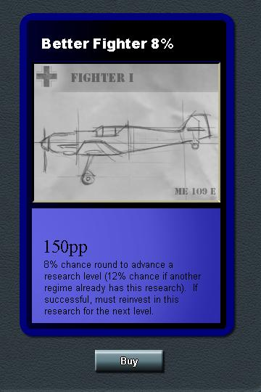
3. I shift around production a bit. I was using Berlin to produce the steel, engines and pilots I will want for France. After 2 turns, I have enough of these resources in my pipeline. I shift production to elite infantry. These can be para dropped and I will make 6 units of 10 for the assault against Norway. With the Royal Navy in the South Atlantic, I think it is worth risking an early attack on Norway. I use Warsaw to make more resources, but at a lower level. This gives me some flexibility if I need additional units vs either France or in the Balkans in late 1940.
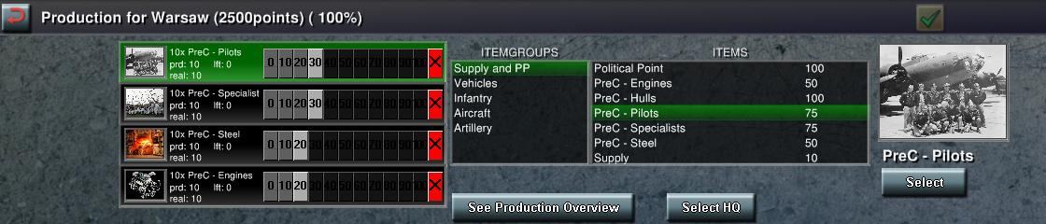
4. Most of my army is moving to the French and Belgian border. I peal off Guderian, a fast engineer, an armor and a mech for the upcoming offensive vs Denmark. I would like to seize Copenhagen and Aalborg on the first turn. I make sure that I do not leave my mech unit or Guderian on the North Sea as this would be an easy target for an alert Allied player.
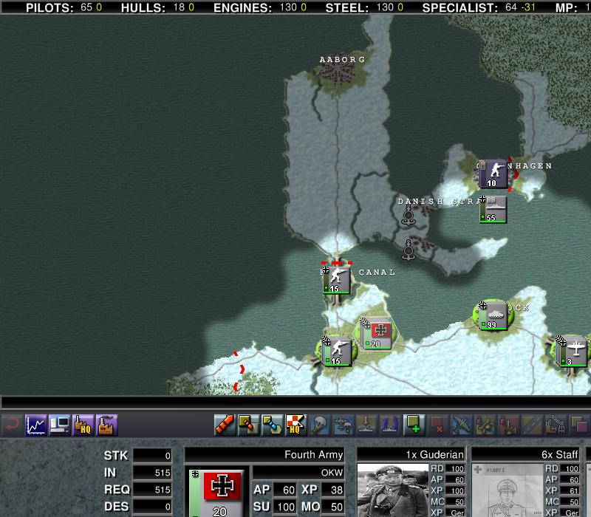

Turn 7. January 23, 1940
1. I launch an invasion of Denmark and Norway. This requires a few turns of prep and should take 3-4 turns to accomplish.
2. To set up, I put Guderian along with a mechanized infantry, an armored and an engineer unit south of the Danish boarder in Kiel. The purpose of this group is to dash north to Aalborg. I also have an infantry unit ready to capture the Western part of the Danish Strait.
3. The fleet is just south of Copenhagen and I have a cargo ship unit loaded with 2 infantry divisions.
4. I construct 60 elite infantry over the course of 2 turns. The first 30 were constructed the previous turn and are organized into units of 10. This is the maximum amount that can be carried by a single level bomber. I also make 3 level bomber units with 1 plane each. Note the that second wave of 30 elite infantry has arrived in my HQ and will be organized into 3 groups of 10 this turn.
5. My dive bombers and half my fighters are already pre-positioned in Rostock. They will attack both Copenhagen Aalborg. My level bombers are moved to the Baltic coast to strike against Olso.
6. The attack goes well. I play an action card to start the offensive. The Danes and Norwegians are surprised and take a 50% readiness reduction. I bomb Copenhagen with my navy and strafe with fighters and dive bombers. The first division from my cargo ship lands and easily mops up the rest.
7. Aalborg is also hit by dive bombers. My mechanized infantry and armor moves in to capture the town. My engineers quickly follow and repair the damage.
8. My second amphibious division is dropped SW of Olso. I also drop two para regiments north of the city. My level bombers attack to reduce effectiveness. Finally, my last para regiment is dropped just to the east of the iron ore resource hex. This serves to cut supply.
9. The Olso units are badly shaken and cut off from supply. I rebase my fighters to the newly captured and repaired Aalborg. They will strike Oslo in preparation to my planned 3 hex side assault.
10. Finally, I position a sub in the North Sea to intercept any sea transfers. I do not risk my surface fleet here.
11. Case White is certainly feasible with effective use of air power (both planes and paras). The key is to use air power and paras to reduce and then capture the key objectives (e.g., Copenhagen, Olso and then the iron ore resource) in stages. The picture below shows the before and after.
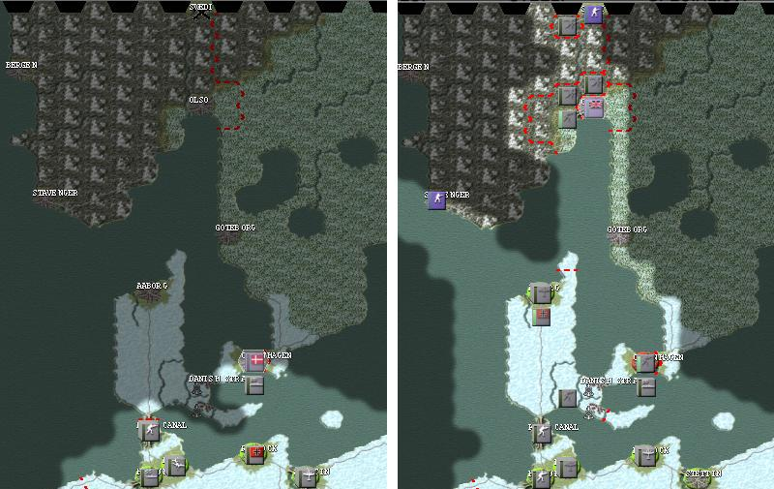

Turn 8. February 16, 1940
1. The second turn of the operation against Norway. I do a para drop in an undefended Stavenger. I assault Olso by air and then by land and capture the capital. I also launch a few bombing runs against the Iron Ore resource hex to soften it up. The allies have sent troops to Bergen. It will be tough to evict them.
2. The picture below shows my position at the end of the turn. Note the resource bar at the top. I have been steadily building pre-cursors with the production from my captured cities. I want to have a good amount of engines, pilots and steel for the coming campaign against France.
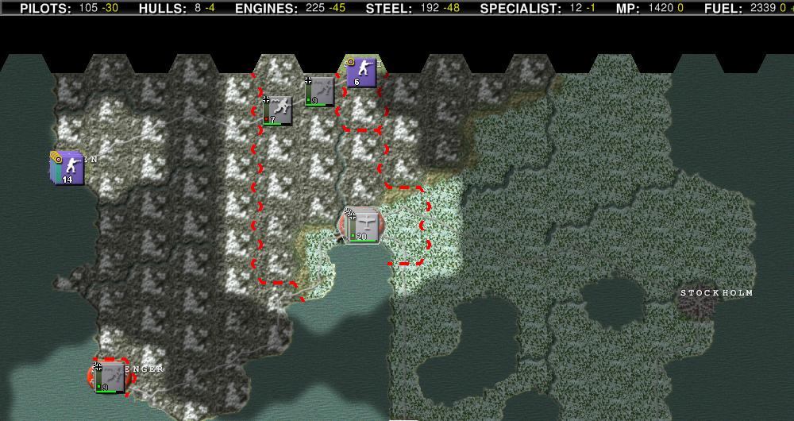
Back to WAW scenario

