WAW Production Walk Through
Germany wants to production Level Bombers for raids on the West. Production in Berlin is selected and the German player can see that each Level Bomber will cost 1 pilot and 2 engines. These are called pre-cursors and they vary by unit type. Light tanks, for example, cost 1 engine and 1 steel.
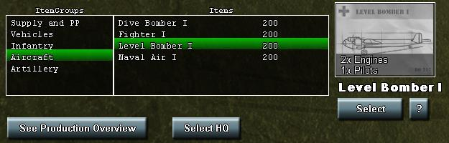
The Germans have 10 pilots and 20 engines so 10 Level Bombers can be produced. However next turn, there is a problem. The Germans have no more pilots or engines available. This can be seen on the resource bar:
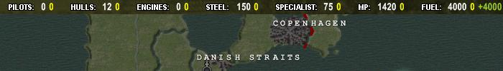
The white number next to the pilots and engines tell you how many of the pre-cursor is available. You can also play the 'show production pipeline' action card to see how many pilot and engine precursors are in the production pipeline:
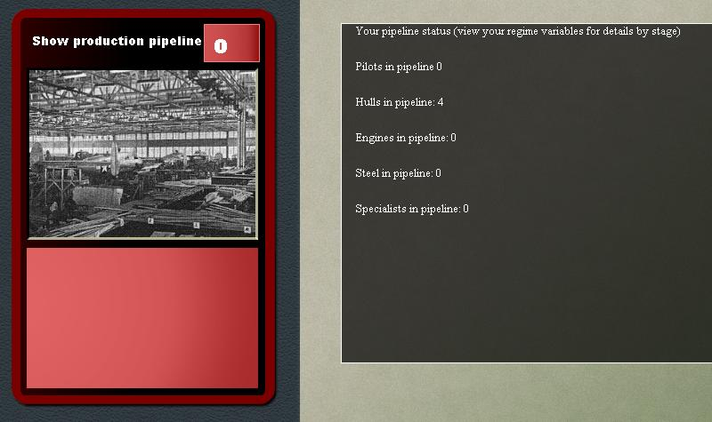
Unfortunately, you have no pilots or engines in the pipeline. This can also be confirmed by looking at your regime variables:
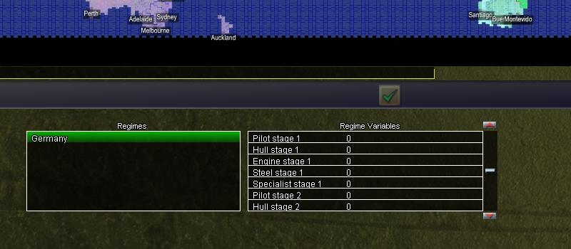
Scrolling through this shows that PreC - Pilot, Pilot Stage 1, Pilot Stage 2, Pilot Stage 3, Pilot Stage 4, Pilot Stage 5 and Pilots are all zero. The same is true with engines. We will have to build both if we want to make any more Level Bombers. You build pre-cursors by playing the appropriate action cards:
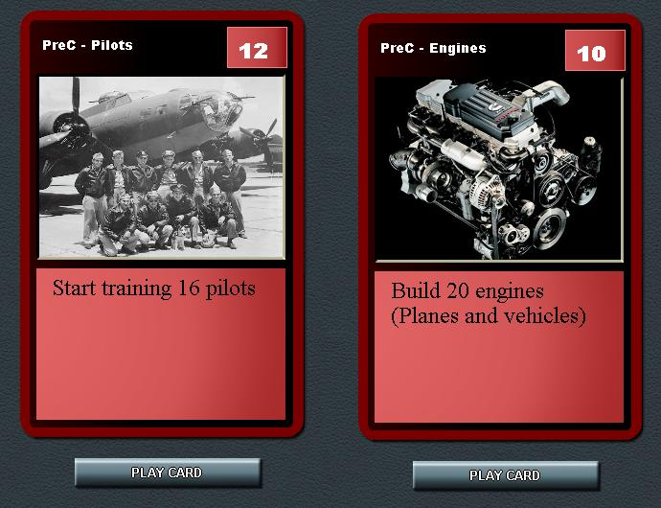
Or by using city production. Germany choses to use Berlin Production to make 20 pilots and 40 engines. This will be enough to build 20 Level Bombers once the pre-cursors are ready:
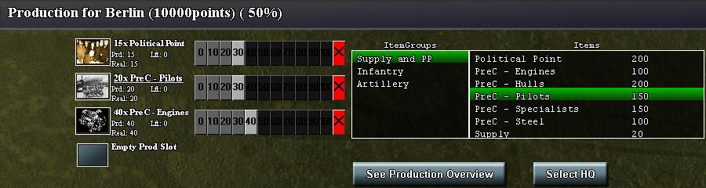
The next turn, Germany has 20 pilot and 40 engines at the stage 1:
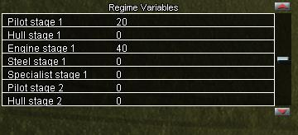
Over the next couple of turns, these pre-cursors rise in stage (1 stage increase per turn):
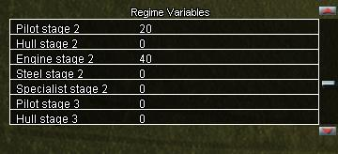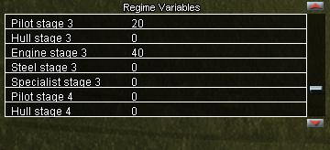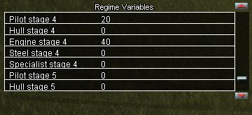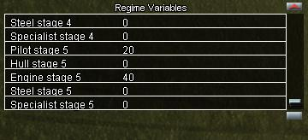
After stage 5, both the pilots and engines are ready for production. You can now see them on the resource bar:
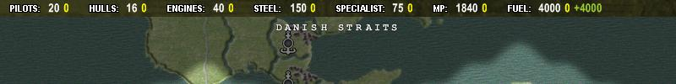
You can now switch Berlin production (or any other site) to make 20 Level Bombers:
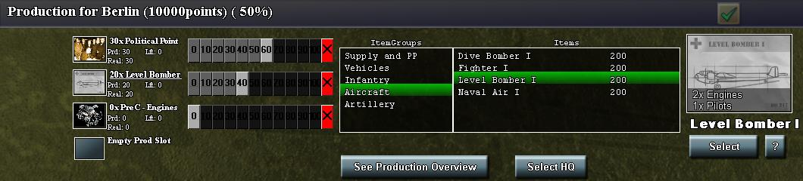
Note that the resource bar shows a negative number next to your pilot and engines. This shows the number of resources consumed across all your production sites. If the number is yellow, it means you have enough pre-cursor to make all the units you would like to make. Right now, the number of pilots and engines exactly meets the demand:
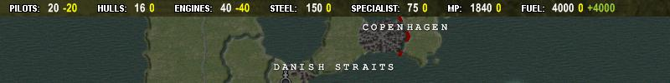
If you try to make more Level Bombers, you will not be able to. Look what happens if you try to make 40 Level Bombers:
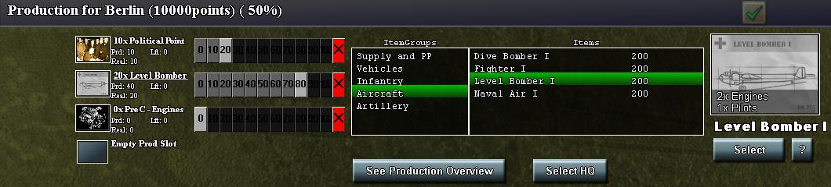
You can see the 40 trying to be produced (40 Prod) but only 20 are realized (20 Real). The unrealized production is wasted. You can also tell there is a problem by by looking at the resource bar. If the sum total of all production (e.g., tanks also use engines) requires more precursors than you have, then then negative number on the resource bar is red:
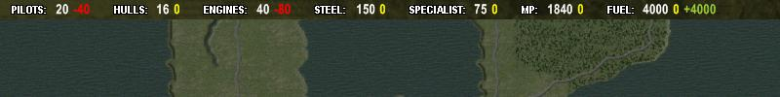
Always make sure you resource bar is not red before hitting 'next turn' so you are not wasting production. That is basically it. The key is to plan your needs ahead as it will take a will to make pre-cursors. You can speed the process through research. Germany starts with a special production delay due to economic disorganization. Produced pre-cursors start in Stage 1 (everyone else's start in Start 2) . This means it takes an extra turn to make the pre-cursors. Play the 'Production Reorganization' card to remove this special penalty:
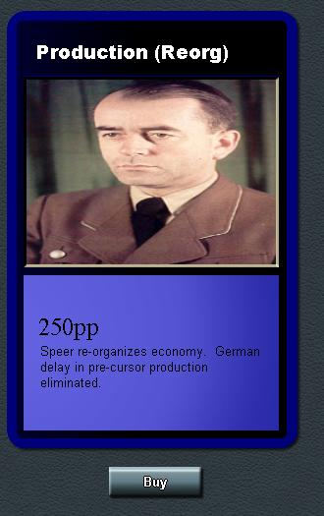
All players (and Germany once the 'Production Reorg' card is played) can further improve pre-cursor completion speed through research. This research allows you to skip 1, 2 or 3 stages of pre-cursor production respectively:
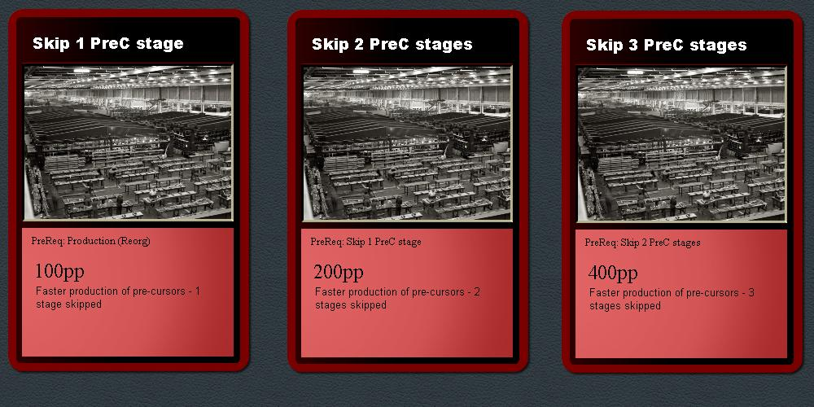
Note that if you skip 3 stages, your pre-cursors will be produced at stage 5. The total time to make both pre-cursors and the final unit is now 3 turns (e.g., 1 turn to make pre-cursor to stage 5, one turn to finish the pre-cursor and one turn to make the unit.
Note also that hull pre-cursors only move up the stages on even turns. In effect, hulls take twice as long to make.
Go back to WAW production

