Production
I. Production is as critical to winning as the correct deployment of units. World at War uses a three stage process to simulate the time it takes to create units and put gearing limits in place.
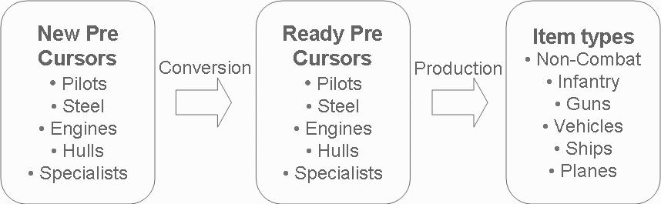
1. Players must first order the production of pre-cursors (pilots, engines, steel, hulls and specialists). Precursors can be ordered through the playing of action cards. They can also be created by cities. Pre-cursors are originally in the 'new' state (e.g., new pilots, new engines, new steel, new hulls and new specialists).
2. Every turn, the precursors advance a stage. Ships only advance on even numbered turns. After getting to stage 5, the precursors become ready for production. Note that research can improve the conversion rate by allowing players to skip stages. Bottom line is that it takes 5 turns to make a pre-cursor (10 for hulls) before conversion improvement. In effect, it takes 6 turns lead time to order tanks, artillery, plains and specialists. Improved conversion means that the economy of the country is more efficient. Less production is 'stuck' in the system.
3. Once a 'ready' pre-cursor is available, then it can be used in production. The number of ready pre-cursors is shown on the resource bar at the top of the screen. Below you can see a screen shot from Germany's first turn. The German player has 26 pilots ready, 11 hulls, 55 engines, 53 steel and 27 specialists ready. If you select a city for production (in the picture below, Berlin is selected) and select a item for production, the number of pre-cursors is shown (below you can see that Figther I is selected and each fighter requires 1 engine and 1 steel). Be careful not too try to produce more items than you have precursor's for. In the picture below, Germany has ordered the production of 50 fighters but only has the pre-cursors for 26. The remaining production will be loss. You can see this by noting on the bottom left the 'real' is 26 while 'prod' is 50. The resource bar also shows how many pre-cursors will be consumed next turn. In the example below, 50 engines and 50 pilots are on order (-50 next to engines and pilots respectively). Since there are not enough pilots to meet this order, the -50 for pilots is in red. Players should always make sure they check the resource bar before ending their turn to make sure they are not ordering too many units. This is especially important in managing production across multiple locations.
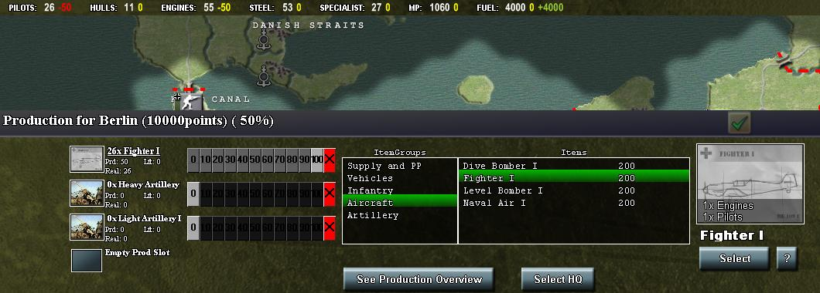
Item costs and precursor requirements are shown below.
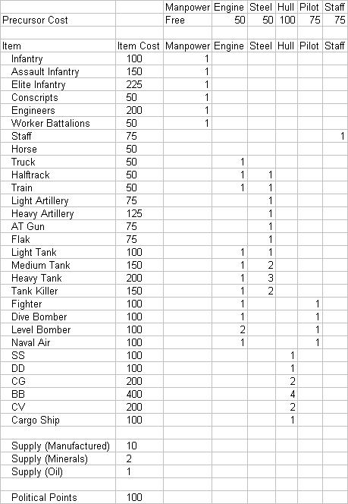
Finally note that the number of new and ready precursors can be seen by playing the 'Show Pre-cursors' card.
II. Production can be increased through research. Player's can improve the production of their own people (e.g., Germany can improve German production), of European people (e..g, Eastern Europe, Low countries, Spain, Scandanavia) and Non-Euro people (Asia and Latin America). The cost of the research is set each turn based the production of the people to be improved. The level of production by people type is can be seen by playing the 'Check people production' card. It is important to gear up production as quickly as possible. This is the first research players should conduct. Note that most regimes start at 50% production while Euro and Non-Euro people's production starts at 25%. The US production level starts at 25% as does the Soviet production level if the 'World wide revolution' variant is selected.
III. Supply. There are 3 classes of supply. Manufactured supply costs 10 pp and can be built in cities. Minerals costs 2 pp and can be built out of minerals locations (e.g., Bratislava) or chemical factories (e.g., Lille, Dresden). Oil cost 1 pp and can be built out of oil locations (e.g., Ploesti). Players should ensure supply needs are met by minerals or oil. Build chemical factories rather than rely on supply from cities. Note that resources and oil locations can only produce supply and have a separate people type (e.g., resource people). As such, they can not be improved by production research.
IV. Factories. These are specialized production locations. They have a higher production rate than cities but have a limited range of production capabilities. Factories are manned by factory people and are immune from production research improvements. Players can build air factories (e.g., Willow Run), ship factories (e.g., Bath Iron Works), gun factories, vehicle factories and chemical factories (build resource supply). Players should only build factories after production and conversion is improved. Factories require a steady stream of pre-cursors to be efficient
V. Fuel. A unit of fuel is produced with every supply. Fuel is consumed every time a plane, vehicle or ship moves or fights. If a player runs out of fuel, they will be less effective. The Allies have large reserves, fuel management is most important for the Axis powers. Note fuel is not saved from turn to turn.
Back to WAW scenario

